

| **TITLE : To perform time series analysis on health care** |
| --- |

**AIM:** To perform forecasting using time series analysis

**Expected OUTCOME of Experiment:**

CO4: Perform Time series Analytics and forecasting

**_____________________________________________________________________**

**Books/ Journals/ Websites referred:**

Students have to list.

**_____________________________________________________________________**

**Pre Lab/ Prior Concepts:**

Students should have a basic understanding of: Time series Analytics and forecasting

**Procedure:**

**Data set Used: Hospital_patients_datasets**

**Step1: Select and Load the dataset**

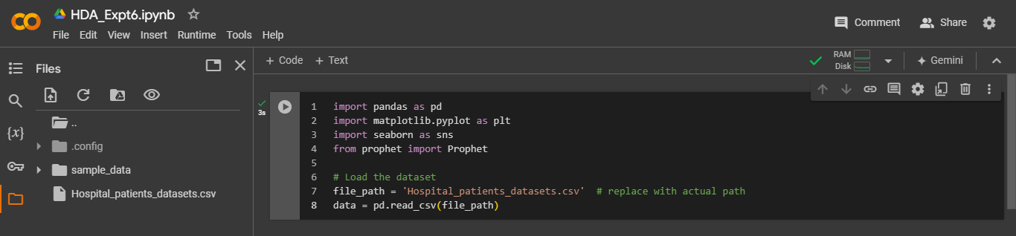

**Step2: Convert 'ScheduledDay' and 'AppointmentDay' to datetime format**



**Step 3: Forecasting Daily Attendance**

**Step4: Initialize Prophet model for forecasting**

**Step 5: Fit the model**

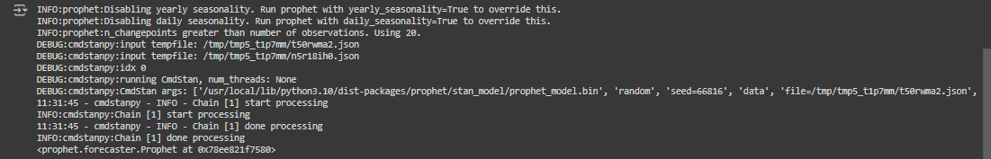

**Step 6: Predict future attendance**

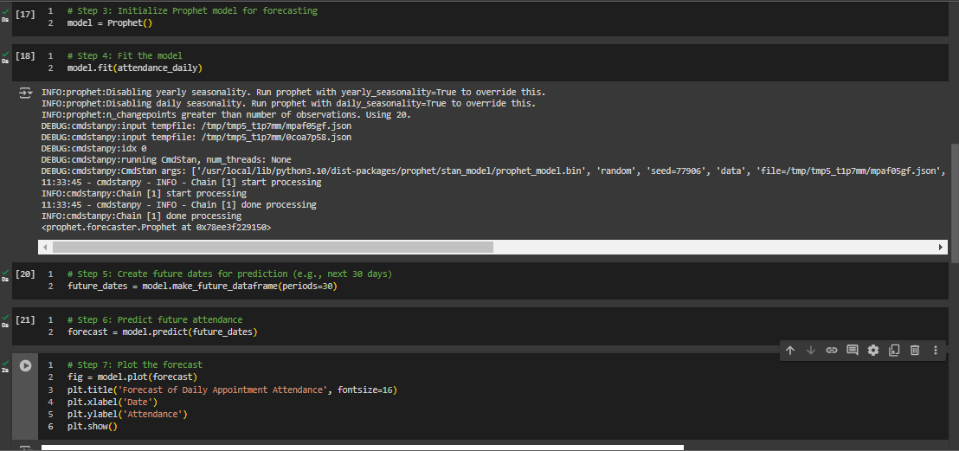

**Step 7: Plot the forecast**

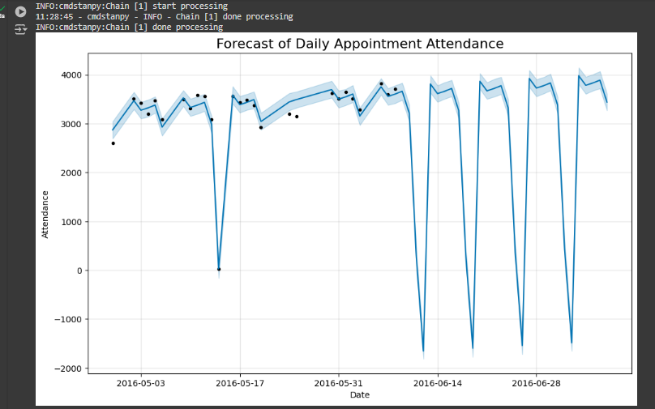

**Step 8: Exploratory Data Analysis Functions**

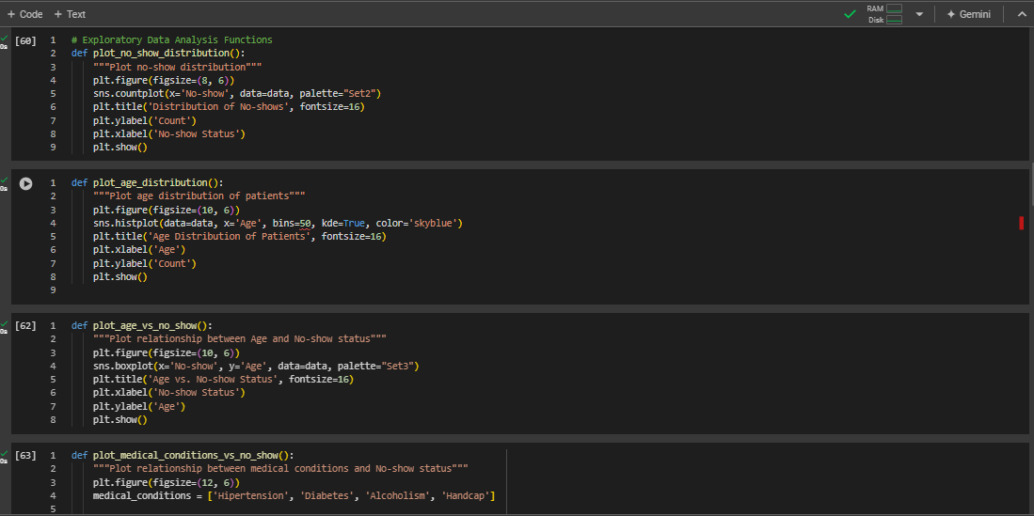

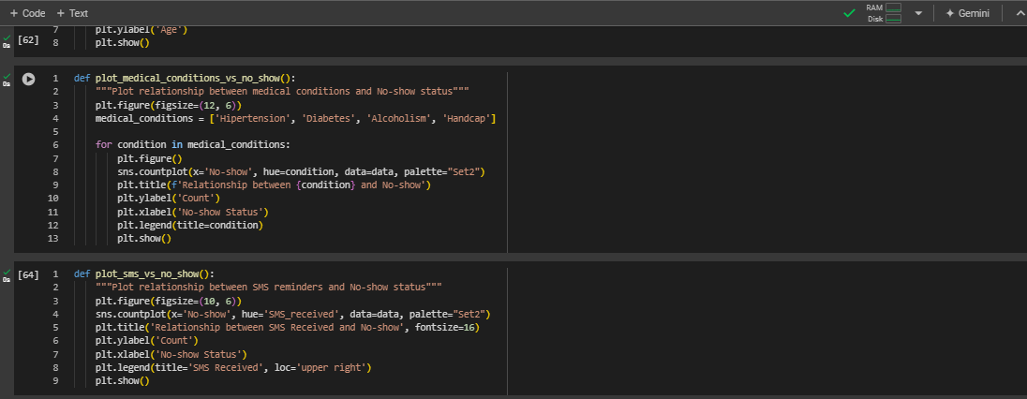

**Step 9: Running the analysis functions**

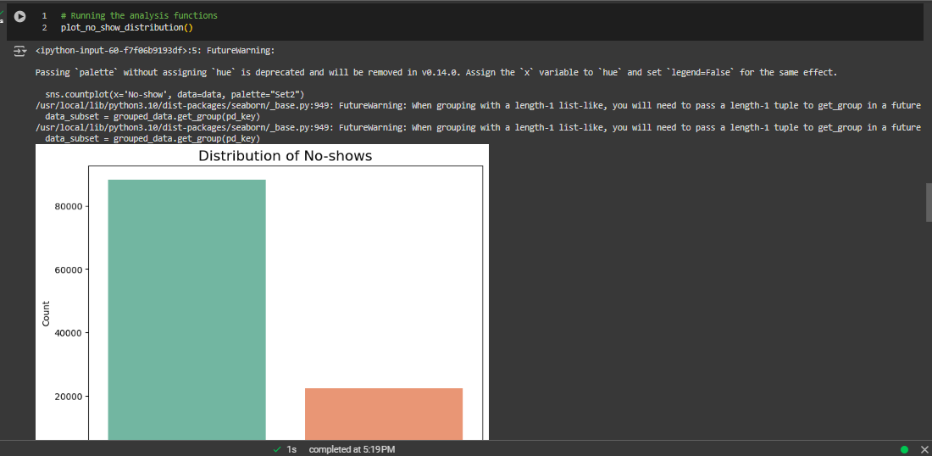

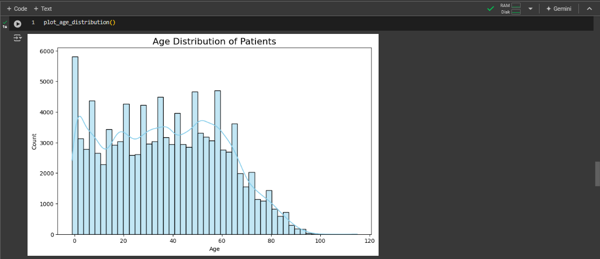

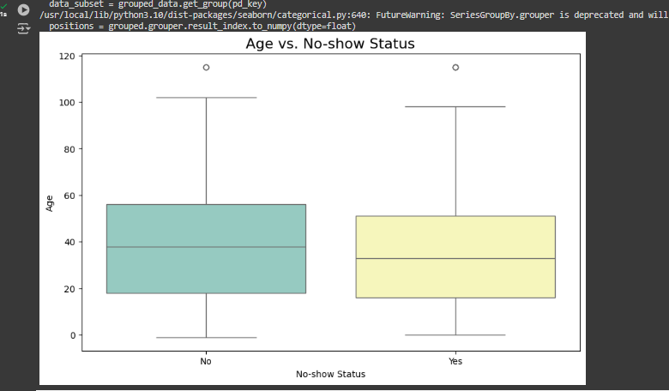

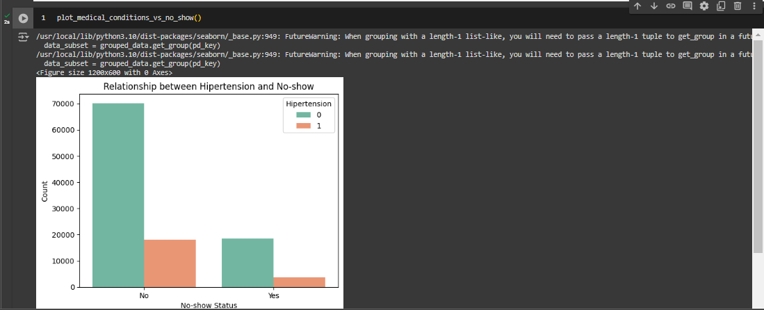

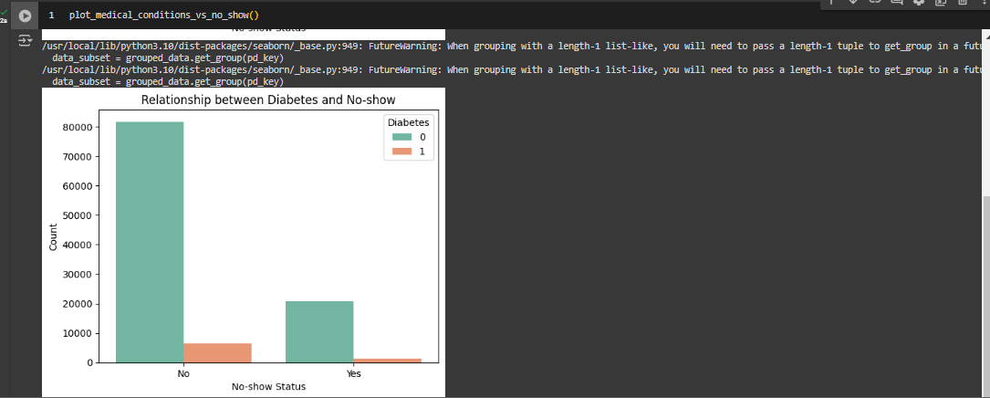

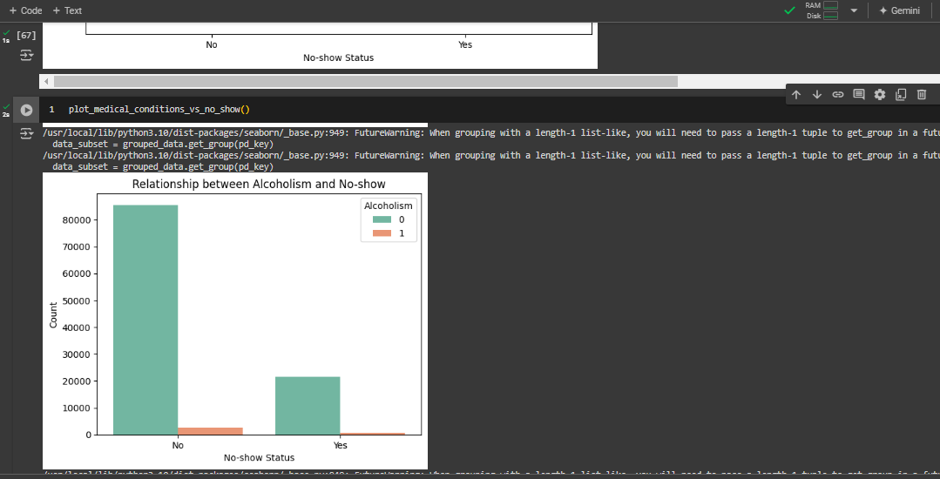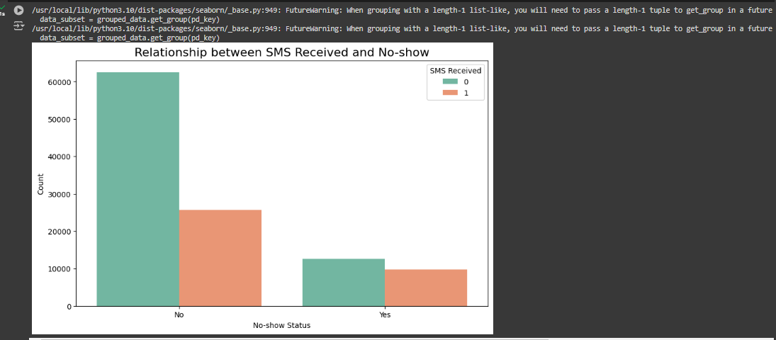

Implementation details:

Analysis of Gender vs Diseases

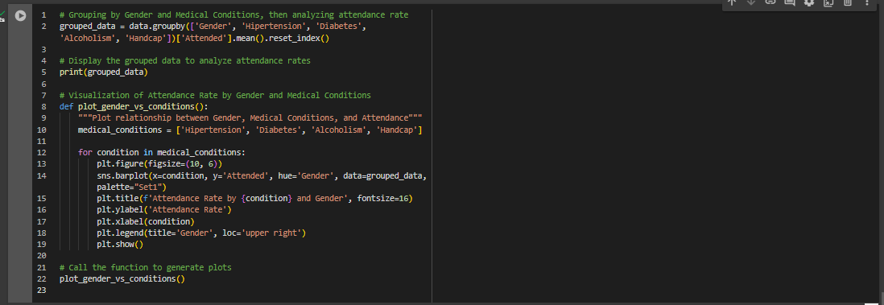

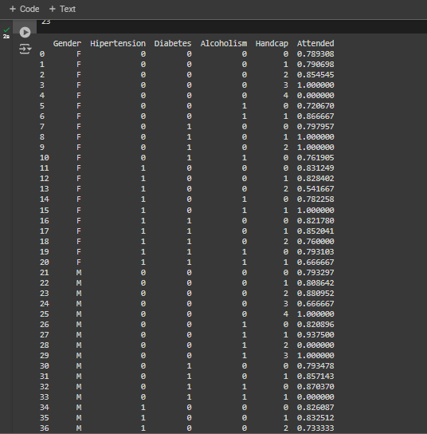

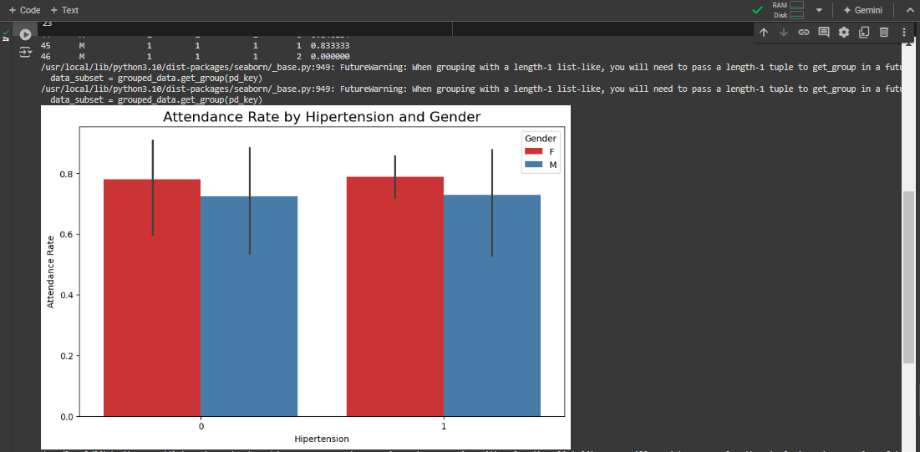

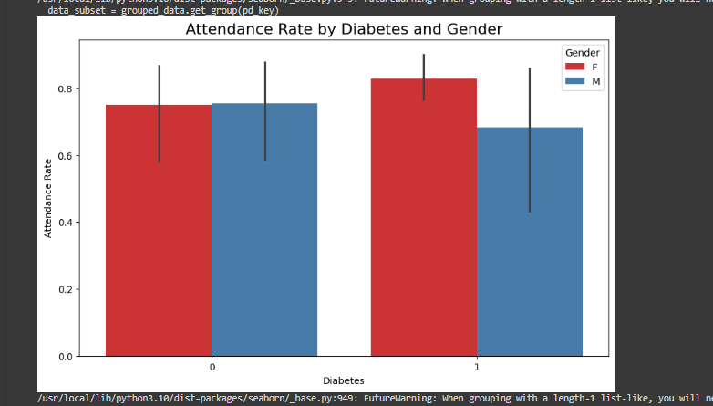

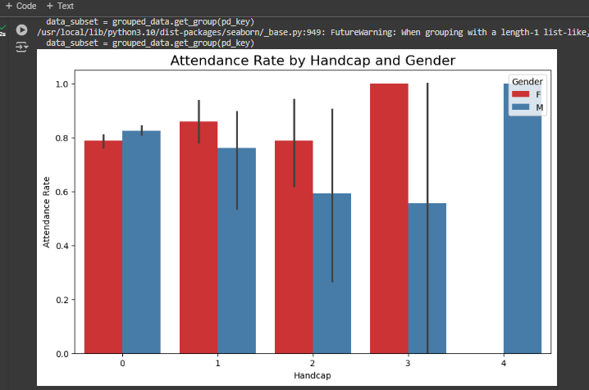

Code file (Google Colab): [HDA_Expt6.ipynb](https://colab.research.google.com/drive/1ww-F6i_S_BHHwmPPcztUt7IbzFNfeT3i?usp=sharing)

**Date: _____________ Signature of faculty in-charge**

**Post Lab Descriptive Questions:**

1. Explain the components of time series?
2. How do you handle seasonality in time series data? What methods or transformations can you apply?
3. What are some common metrics for evaluating forecasting models (e.g., MAE, RMSE, MAPE)?